Mr Andrea GAVINELLI
Head of Unit
Official controls and eradication of animal diseases
DIR G Crisis Management in Food, animals and plants
DG for Health and Food Safety
European Commission
Rue Breydel 4
1000 Brussels
Belgium

26/9/2019

European Commission consultation on COMMISSION IMPLEMENTING REGULATION (EU) …/...
of XXX establishing detailed rules on the operations to be carried out during and after documentary checks, identity checks and physical checks on animals and goods subject to official controls at border control posts

Dear Mr Gavinelli,

On behalf of a number of Thoroughbred horse racing and related organisations I am writing to you directly in relation to the above proposed legislation.

We have particular concerns regarding the requirements in Article 4, and believe that a derogation for registered horses should also be added. Given that nearly all equids are transported in vehicles containing less than 10 animals, at present the text seems to require all equids to undergo an individual identity check and clinical examination.

This would mean that almost all equids will have to be fully unloaded, even though, in the case of Thoroughbreds, their documentation already attests to their high health status.

In terms of Thoroughbred racehorses and bloodstock, this would undoubtedly cause unnecessary stress and risk of accidents, as well as unnecessary potential exposure to disease. It would also lead to unnecessary delay at BIP crossings leading to further potential welfare problems.

Documentation for Thoroughbred horses can already demonstrate a high health status. The fact that these horses are destined for either competitive races, bloodstock sales, or arriving or returning from stud, means that it is in the interest of owners and transporters to keep these horses in prime physical condition.

Particularly in the case of all pregnant mares, foals, or youngstock, the requirement for unloading and reloading to undertake individual identity and clinical checks, simply places unnecessary stress on these animals, as well as potentially introducing them to additional disease risks. It also unnecessarily prolongs their journey. None of these factors is in the welfare interests of our high-value equids. In addition, these requirements will place an additional unnecessary workload on BIP officers.

Therefore, we believe it is in the health and welfare interest of higher health equids who have equivalent equine epidemiological health status to the export/import state, for this legislation to allow, at the very least, for member states to be able to apply a derogation from individual identity checks and clinical examination.

We see from other consultation responses published on the European Commission website that our concerns are also shared by major equine welfare and sports horse organisations. We all agree that this proposal is neither in the health nor welfare interests of equines travelling through BIPS.

Given your previous experience in animal welfare policy we urge you to take our concerns seriously and change this proposed legislation. We stand ready to assist you in any technical or further information needed, or to meet with you or participate in any stakeholder discussions on the subject.

Yours sincerely,

Paull Khan

Dr Paull Khan
Secretary-General
European and Mediterranean Horseracing Federation

On behalf of
THE EUROPEAN & MEDITERRANEAN HORSERACING FEDERATION (EMHF)
THE EUROPEAN & AFRICAN STUD BOOKS COMMITTEE (EASBC)
THE EUROPEAN FEDERATION OF THOROUGHBRED BREEDERS’ ASSOCIATIONS (EFTBA)
THE EUROPEAN TRAINERS’ FEDERATION (ETF)
THE ANIMAL TRANSPORTATION ASSOCIATION (ATA)

EMHF
EUROPEAN AND MEDITERRANEAN HORSERACING FEDERATION
The EMHF’s 27 members are the governing bodies for Thoroughbred horseracing in the region. Nineteen of the EMHF’s member countries are EU Member States.
The EMHF was founded to co-ordinate the promotion of Thoroughbred horseracing in the region, to bolster its prestige and protect its integrity, and to develop relations between the organisations responsible for running the sport. The main objective of the EMHF is to develop relations among European and Mediterranean Horseracing Authorities, to coordinate promotion of horseracing in Europe and in Mediterranean countries, to defend the latter's integrity and prestige throughout the world and to represent the interest of European horseracing before the European Union bodies.
The EMHF is the continental federation within the global International Federation of Horseracing Authorities. More details can be found at www.euromedracing.eu.

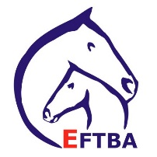
THE EUROPEAN FEDERATION OF THOROUGHBRED BREEDERS ASSOCIATIONS
EFTBA was set up in 1994 to enable European breeders’ associations to be represented at a European level with a strong single voice. The federation represents the majority of European Thoroughbred breeding countries, and welcomes countries currently outside the European Union. EFTBA members are independent and autonomous bodies, representative of the Thoroughbred breeding industry within their countries. They represent major breeding nations as well as countries where the bloodstock industry is not developed at its full potential. Combining member countries with such a variety of profiles operates as a booster and can raise the general quality of Thoroughbred breeding programmes in Europe. EFTBA contributes to the expansion of the market for Thoroughbred horses in Europe and worldwide. The Thoroughbred breeding and racing industry is a major player in the wider EU horse sector making a significant economic impact.
For more information, see https://www.eftba.eu/

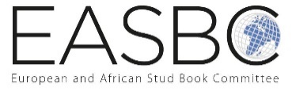
EASBC (European and African Stud Book Committee)
Comprising the Thoroughbred Stud Books of Europe and Africa, there are currently 35 Approved Stud Books in this region and the EASBC Secretariat are working with a number of emerging Stud Books in the area with a view to becoming approved by the International Stud Book Committee (ISBC). EASBC hold a biennial conference for all their member Stud Books, which has in recent years rotated between three host countries of Ireland, France and Great Britain.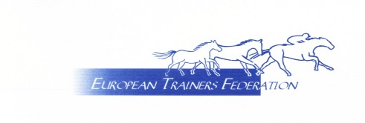
EUROPEAN TRAINERS FEDERATION
The ETF brings together the representative bodies for Thoroughbred racehorse trainers in 12 European countries. The aims and objectives of the ETF are:
- To represent the interests of all member trainers' associations in Europe.
- To liaise with political and administrative bodies on behalf of European trainers.
- To exchange information between members for the benefit of European trainers.
- To exchange information between members for the benefit of European trainers.

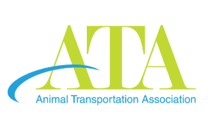
THE ANIMAL TRANSPORTATION ASSOCIATION
The ATA is a non-profit international trade association dedicated to promoting her members and providing access to necessary resources and education for the safe and humane handling and transport of all animals worldwide. ATA was founded in 1976 by a former USDA Officer and three different USDA Departments as they thought there was a lack of information, education and regulation in the live animal shipping industry. Members of ATA include airlines; airports; handlers; shippers; freight forwarders; exporters; government authorities and academic & research organizations who are all involved in the sector of live animal transport, whether by air, road or sea.
ATA provides an important opportunity for individuals, businesses, organizations and groups involved in any phase of animal transportation to become part of an international effort to find solutions to a variety of problems related to the transport of animals. At the same time, members are linked to information, resources, contacts, and key developments in the field that can help them provide better services and conditions for animals in transit. ATA provides a means for making research needs known, encouraging research, and disseminating findings. The organization further encourages uniform and effective international regulations and humane handling of live animals.
For more details, see http://animaltransportationassociation.org/

