Irish School of Farriery Deliver Seminar for European and Mediterranean Horseracing Federation

Twenty-two Farriers from seven European countries attended a seminar delivered yesterday, Thursday 21 August, by the Irish School of Farriery in Kildare Town, County Kildare. Organised by the European and Mediterranean Horseracing Federation (EMHF), delegates from Czech Republic, Germany, Sweden, Turkey, Slovakia, Denmark and Ireland were treated to a day’s tuition, part-classroom, part-practical from two of the most senior practitioners and instructors in Ireland, Alwyn McKeown A.W.C.F and Brian Dunne Dip W.C.F, IMFA.

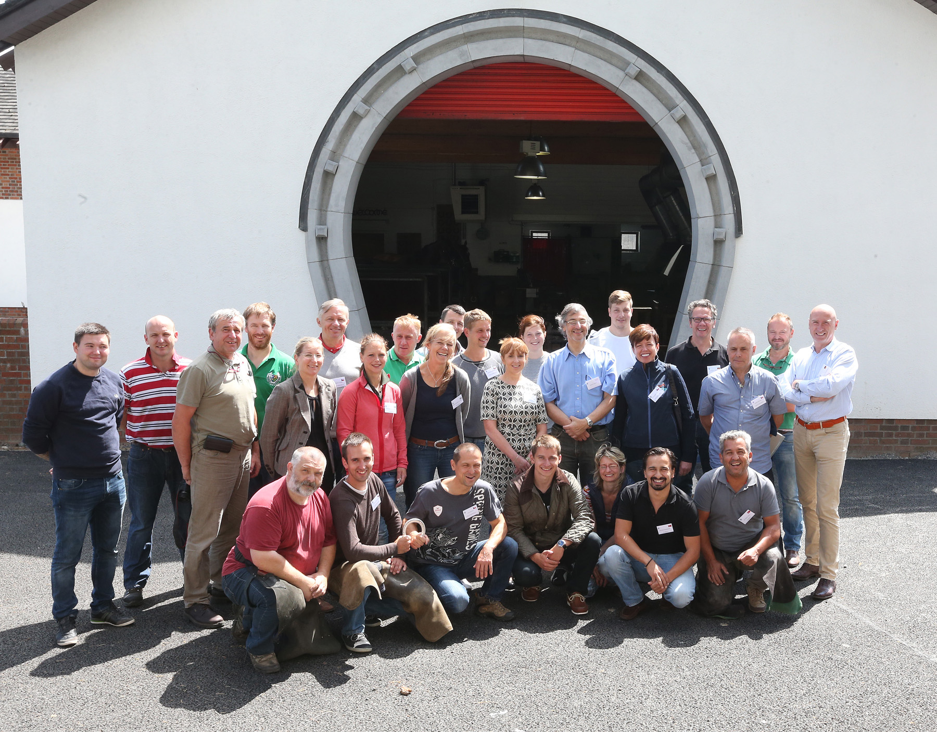
Photo: Caroline Norris

The morning classroom session covered a wide range of subjects including: shoeing a racehorse and shoeing techniques, types of horseshoes, shoeing for various track surfaces, modern products, trimming the racehorse; common types of hoof conditions/injuries including tendon, ligament injuries, cracks and interference injuries. Regulations and rules for the shoeing of thoroughbreds for racing were also discussed.

The afternoon session featured a practical clinic, including trimming and shoeing demonstrations, with participants using the opportunity to gain hands-on guidance.

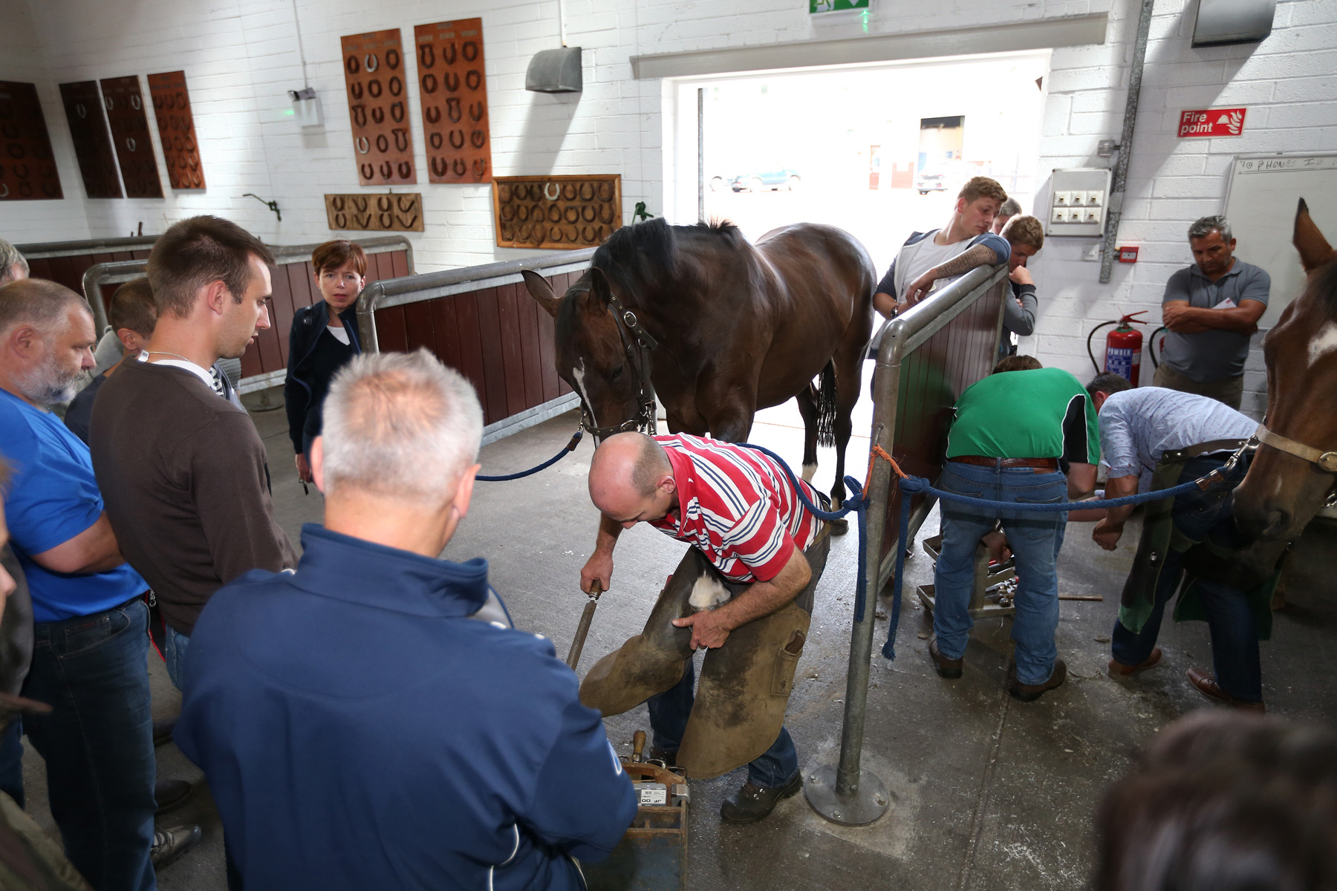
Photo: Caroline Norris

Dr Paull Khan, EMHF Secretary-General, explained: "The EMHF organises seminars every year on all aspects of racing administration. Those member countries with the largest-scale racing industries provide the training, with a view to raising standards across the region. There was a loud call for a seminar on farriery, and Horse Racing Ireland kindly offered to host what was a very well-run event. It was great to see the delegates resolve to maintain contact – they felt that this Seminar will provide the kernel to a racing farriery community across the region that doesn’t exist currently.”

Brian Kavanagh, CEO of Horse Racing Ireland, said: “As Chairman of the EMHF, it’s a pleasure to welcome delegates from so many countries to Ireland for the farriery seminar. Ireland has unique skill-sets in horsemanship and equine husbandry, none more so than our farriers, so I hope all the participants found the seminar very beneficial.”

Stephan Ernesti, a Farrier from Germany, added: All of us thought that this meeting of European Farriers working for the racing industry should meet more often. For us it was good to see the other farriers that were coming from Sweden, Czech Republic and even Turkey. We were so well looked after.”

